LAB TASK 4

**Question 1**

#include<stdio.h>

int main(){

int num;

printf("Enter a number: ");

scanf("%d", &num);

if (num % 3 == 0){

printf("This number is a multiple of 3");

}

else {

printf("This number is not a multiple of 3");

}

}

**Output:**

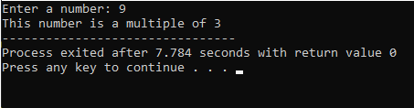

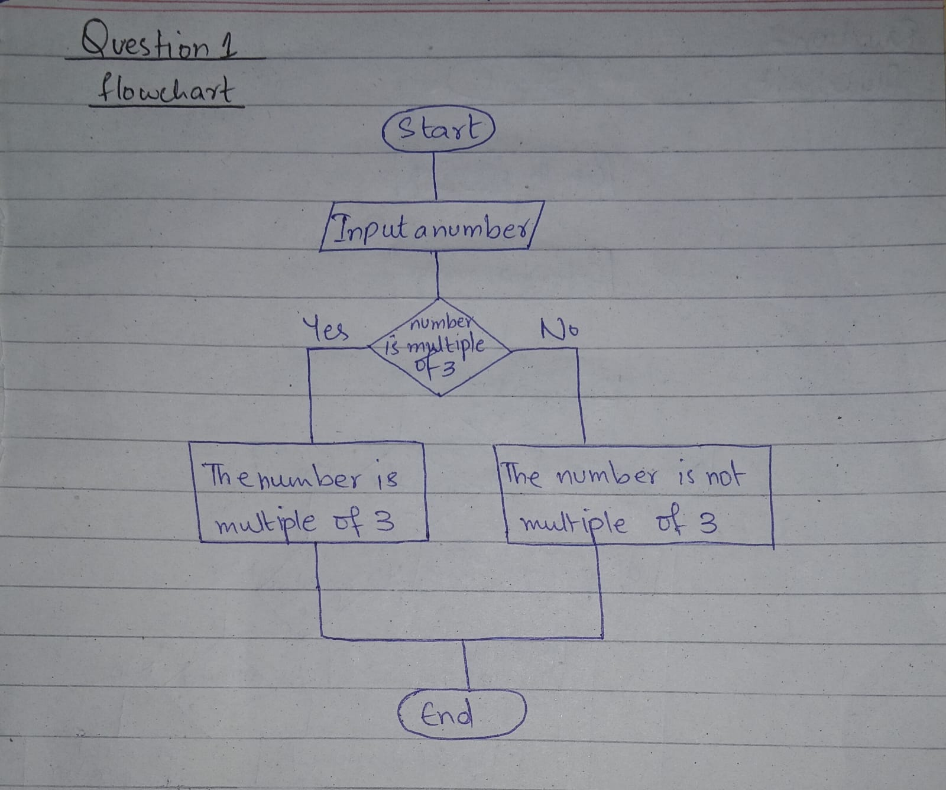

**Question 2**

#include<stdio.h>

int main(){

char op;

int num1, num2, sum, difference, product, quotient;

printf("enter the operator(+,-,*,/): ");

scanf("%c", &op);

printf("enter two numbers:");

scanf("%d%d", &num1, &num2);

switch (op){

case '+':

sum = num1 + num2;

printf("the sum is %d\n", sum);

break;

case '-':

difference = num1 - num2;

printf("the difference is %d\n", difference);

break;

case '*':

product = num1 * num2;

printf("the product is %d\n ", product);

break;

case '/':

quotient = num1/num2;

printf("the quotient is %d\n", quotient);

break;

default:

printf("Error: Invalid Operator\n");

}

}

**Output:**

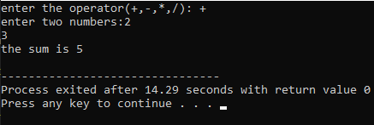

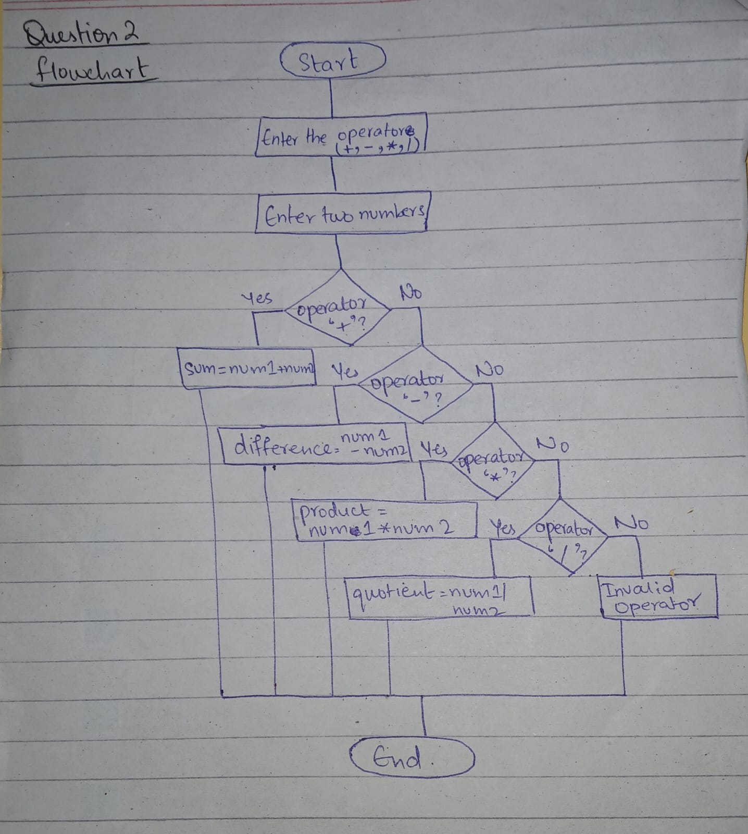

**Question 3**

#include<stdio.h>

int main(){

char ab;

printf("Enter a character: ");

scanf("%c", &ab);

if (ab>= 'a' && ab<= 'z'){

printf("The given character is a small alphabet: %c\n", ab);

}

else if (ab>= 'A' && ab<='Z'){

printf("The given character is a capital alphabet: %c\n", ab);

}

else if (ab>= '0' && ab<= '9'){

printf("The given character is a digit: %c\n", ab);

}

else {

printf("The given character is a special character: %c\n", ab);

}

}

**Output:**

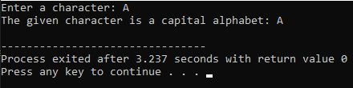

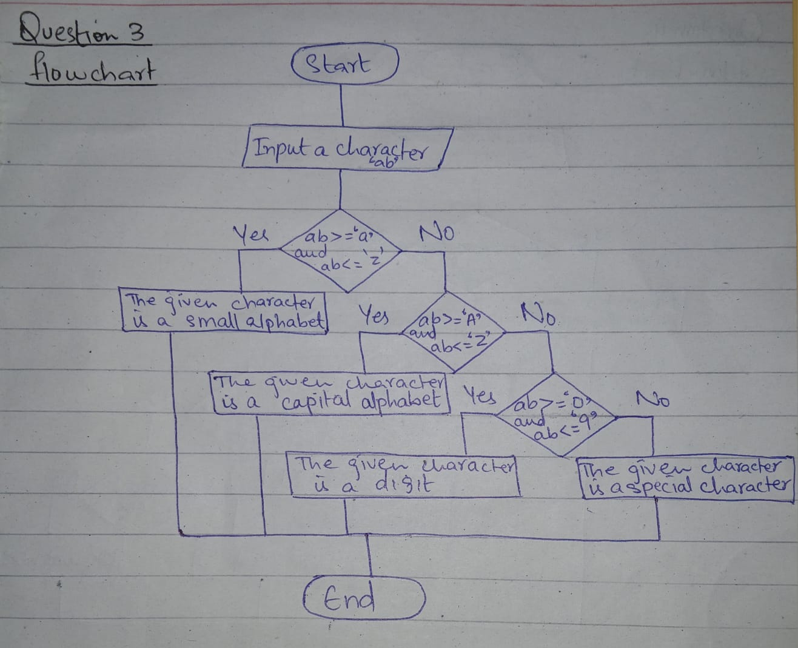

**Question 4**

#include <stdio.h>

int main(){

float ActualAmount, SavedAmount, AmountAfterDiscount, Discount;

printf("Enter the amount of shopping: ");

scanf("%f", &ActualAmount);

if(ActualAmount <= 500 ){

printf("The actual amount is below the minimum amount eligible for a discount");

}

else{

if(ActualAmount<2000){

Discount= 0.05;

}

else if(ActualAmount<=4000){

Discount= 0.1;

}

else if(ActualAmount<=6000){

Discount= 0.2;

}

else{

Discount= 0.35;

}

SavedAmount = ActualAmount * Discount;

AmountAfterDiscount = ActualAmount - SavedAmount;

printf("The saved amount is: %.2f\n", SavedAmount);

printf("The amount after discount is: %.2f\n", AmountAfterDiscount);

}

}

**Output:**

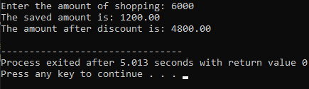

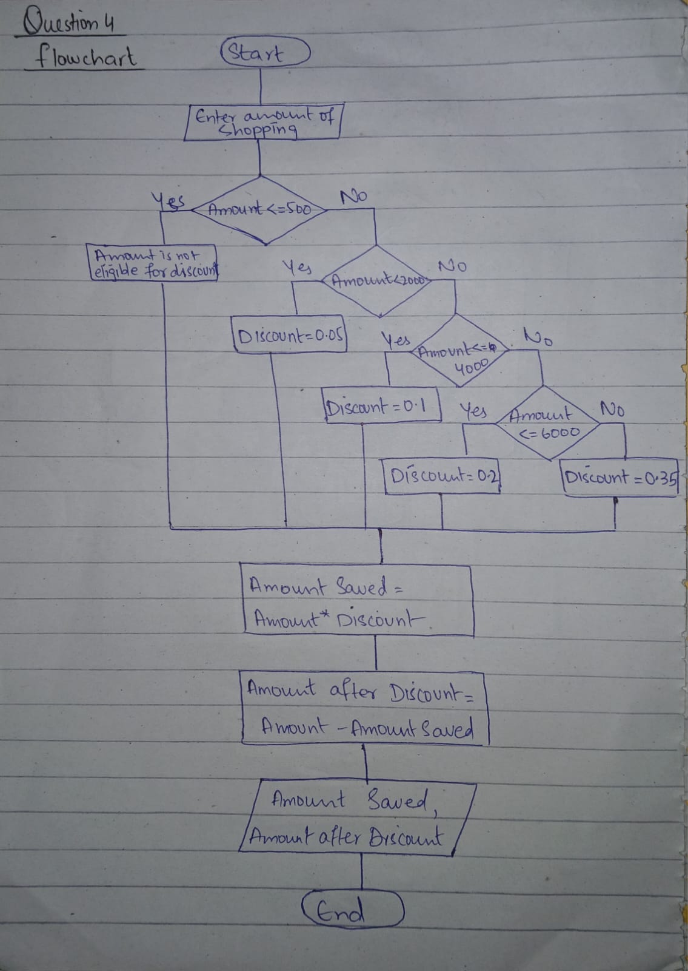

**Question 5**

#include <stdio.h>

int main(){

int customerId;

char customerName;

float unitsConsumed, TotalAmount, FinalAmount, ChargesPerUnit, Surcharge;

printf("Enter Units Consumed:");

scanf("%f", &unitsConsumed);

printf("Enter Customer Id: ");

scanf("%d", &customerId);

printf("Enter Customer Name: ");

scanf("%c/n", &customerName);

if(unitsConsumed<=199){

ChargesPerUnit = 16.20;

}

else if(unitsConsumed>=200 && unitsConsumed<300){

ChargesPerUnit = 20.10;

}

else if(unitsConsumed>=300 && unitsConsumed<500){

ChargesPerUnit = 27.10;

}

else{

ChargesPerUnit = 35.90;

}

TotalAmount = unitsConsumed * ChargesPerUnit;

printf("The total amount is: %f\n", TotalAmount);

if(TotalAmount>18000){

Surcharge = TotalAmount * 0.15;

}

printf("The surcharge amount is: %.2f\n", Surcharge);

FinalAmount = TotalAmount + Surcharge;

printf("The Final Amount is: %.2f\n", FinalAmount);

}

**Output:**

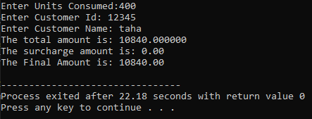

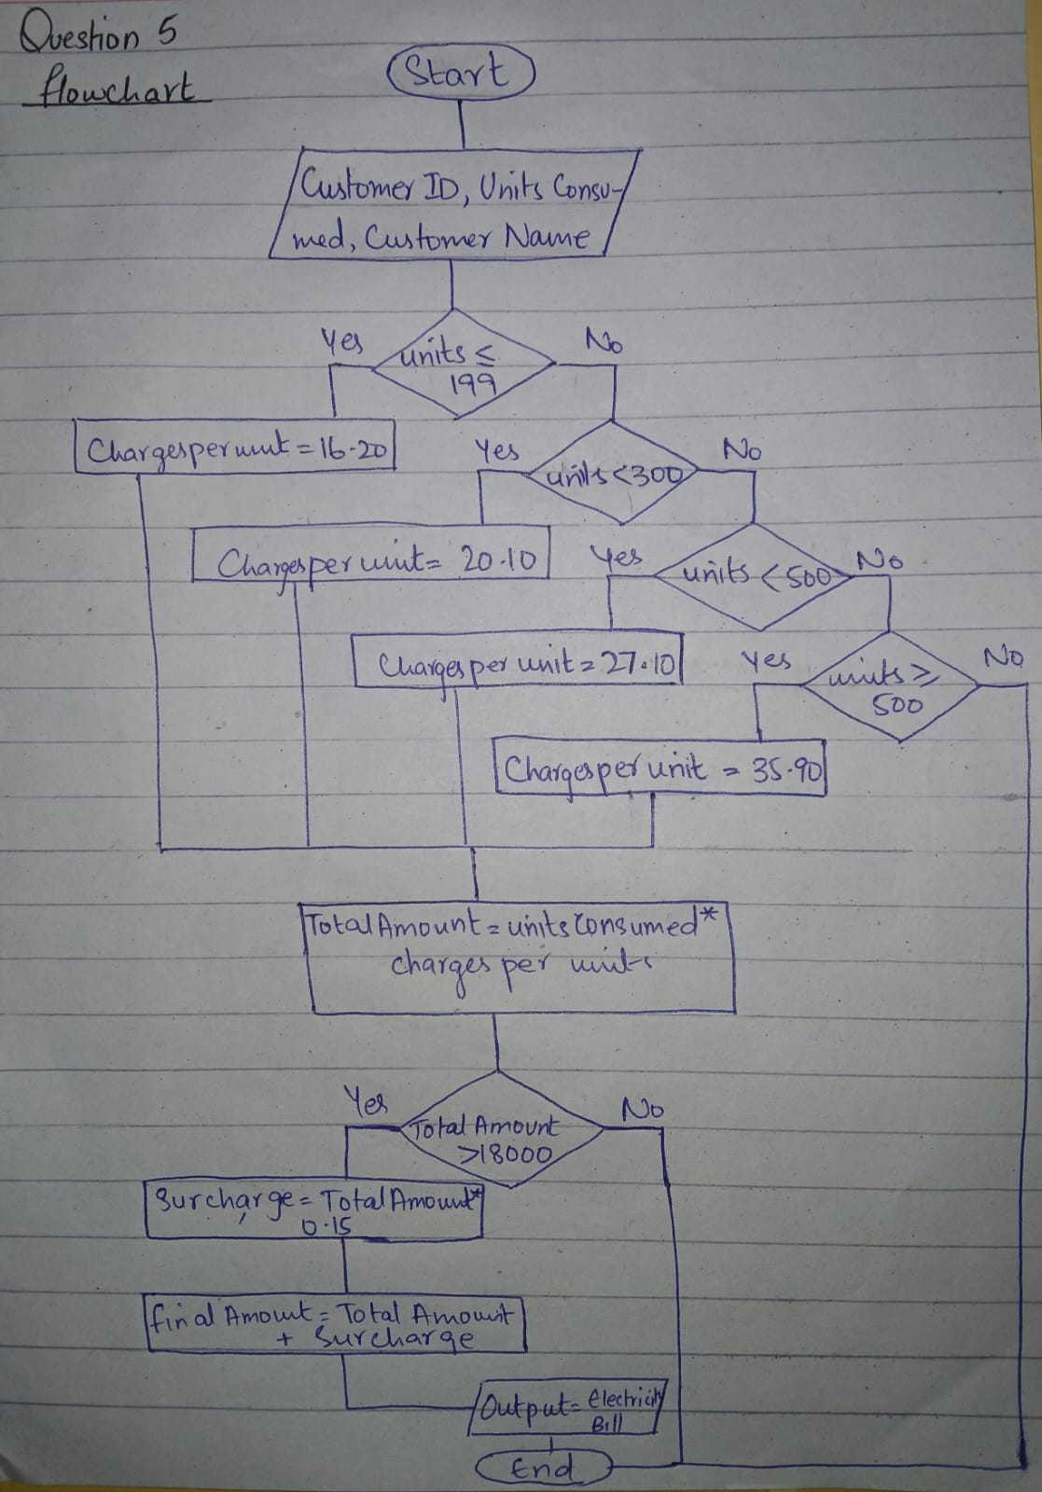

**Question 6**

#include<stdio.h>

int main(){

int n;

printf("Enter a positive integer: ");

scanf("%d", &n);

if(n>=1 && n<=9){

switch(n){

case 1:

printf("one\n");

break;

case 2:

printf("two\n");

break;

case 3:

printf("three\n");

break;

case 4:

printf("four\n");

break;

case 5:

printf("five\n");

break;

case 6:

printf("six\n");

break;

case 7:

printf("seven\n");

break;

case 8:

printf("eight\n");

break;

case 9:

printf("nine\n");

break;

}

}

else if(n>9){

printf("greater then 9");

}

return 0;

}

**Output:**

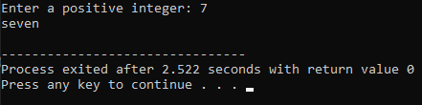

**Question 7**

#include<stdio.h>

int main(){

int light_intensity;

printf("Enter the light intensity value(0-1000): ");

scanf("%d", &light_intensity);

if(light_intensity<0 || light_intensity>1000){

printf("Invalid light intensity value");

}

else if(light_intensity>500){

printf("It's sunshine");

}

else if(light_intensity>=0 && light_intensity<=100){

printf("It's evening");

}

else if(light_intensity>100 && light_intensity<=500){

printf("It's lighting");

}

return 0;

}

**Output:**

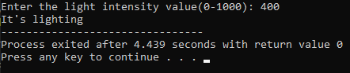

**Question 8**

#include<stdio.h>

int main(){

int hour;

printf("enter the hour(0-23): ");

scanf("%d", &hour);

if(hour<0 || hour>23){

printf("Invalid hour");

}

else if(hour>=5 && hour<=11){

printf("Good Morning");

}

else if(hour>=12 && hour<=18){

printf("Good Evening");

}

else if(hour>18 && hour<=23){

printf("Good Night");

}

return 0;

}

**Output:**

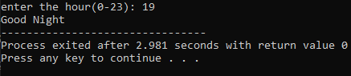

**Question 9**

#include<stdio.h>

int main(){

float nts_marks, fsc_marks, nts_percentage, fsc_percentage;

int total_marks=100;

printf("Enter nts marks: ");

scanf("%f", &nts_marks);

printf("Enter fsc marks: ");

scanf("%f", &fsc_marks);

nts_percentage= (nts_marks/total_marks)*100;

fsc_percentage= (fsc_marks/total_marks)*100;

printf("NTS percentage: %.2f\n", nts_percentage);

printf("FSC percentage: %.2f\n", fsc_percentage);

if(fsc_percentage>70){

if(nts_percentage>=70){

printf("University: Oxford\nDepartment: IT");

}

else if(nts_percentage>=60){

printf("University: Oxford\nDepartment: Electronics");

}

else if(nts_percentage>=50){

printf("University: Oxford\nDepartment: Telecommunication");

}

}

else if(fsc_percentage>=60 && fsc_percentage<=70){

if(nts_percentage>=50){

printf("University: MIT\nDepartment: IT");

}

}else if(fsc_percentage>=50 && fsc_percentage<60){

if(nts_percentage>=50){

printf("University: MIT\nDepartment: Chemical");

}

}else if(fsc_percentage>=40 && fsc_percentage<50){

if(nts_percentage>=50){

printf("University: MIT\nDepartment: Computer");

}

}else{

printf("You are not eligible for any department in any of the universities");

}

return 0;

}

**Output:**

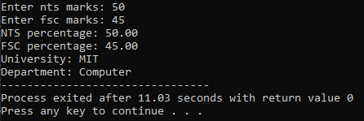

**Question 10**

#include<stdio.h>

int main(){

int temp;

printf("Enter the temperature: ");

scanf("%d", &temp);

if(temp<0){

printf("Freezing weather");

}

else if(temp>=0 && temp<=10){

printf("Very cold weather");

}

else if(temp>=11 && temp<=20){

printf("Cold weather");

}

else if(temp>=21 && temp<=30){

printf("Normal temperature");

}

else if(temp>=31 && temp<=40){

printf("Hot weather");

}

else if(temp>40){

printf("Very hot weather");

}

return 0;

}

**Output:**

